Lab 1 – Setting Up Flutter and Running Your First App

Exercise 1 – Flutter Environment Setup
- Screenshot of flutter doctor
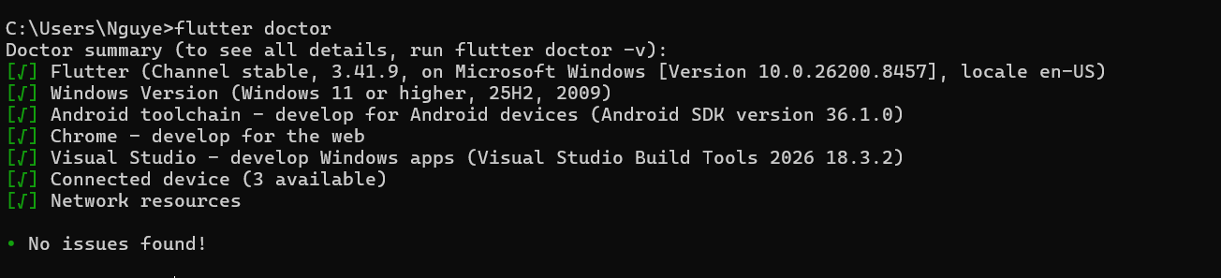

- Screenshot of Flutter/Dart plugin screen
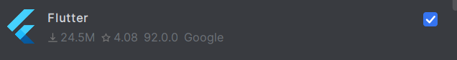
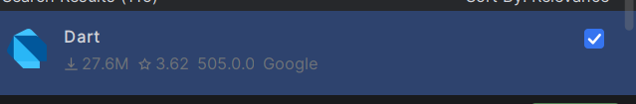

Exercise 2 – Create and Run Your First Flutter App
- Screenshot of project structure
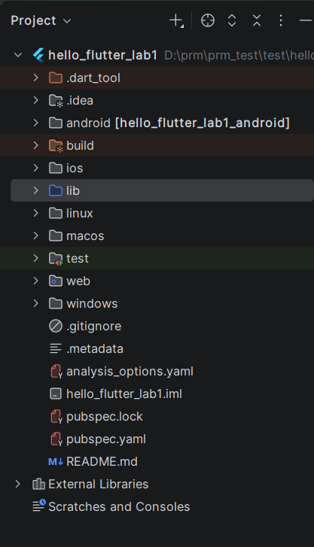

- Screenshot of running counter app
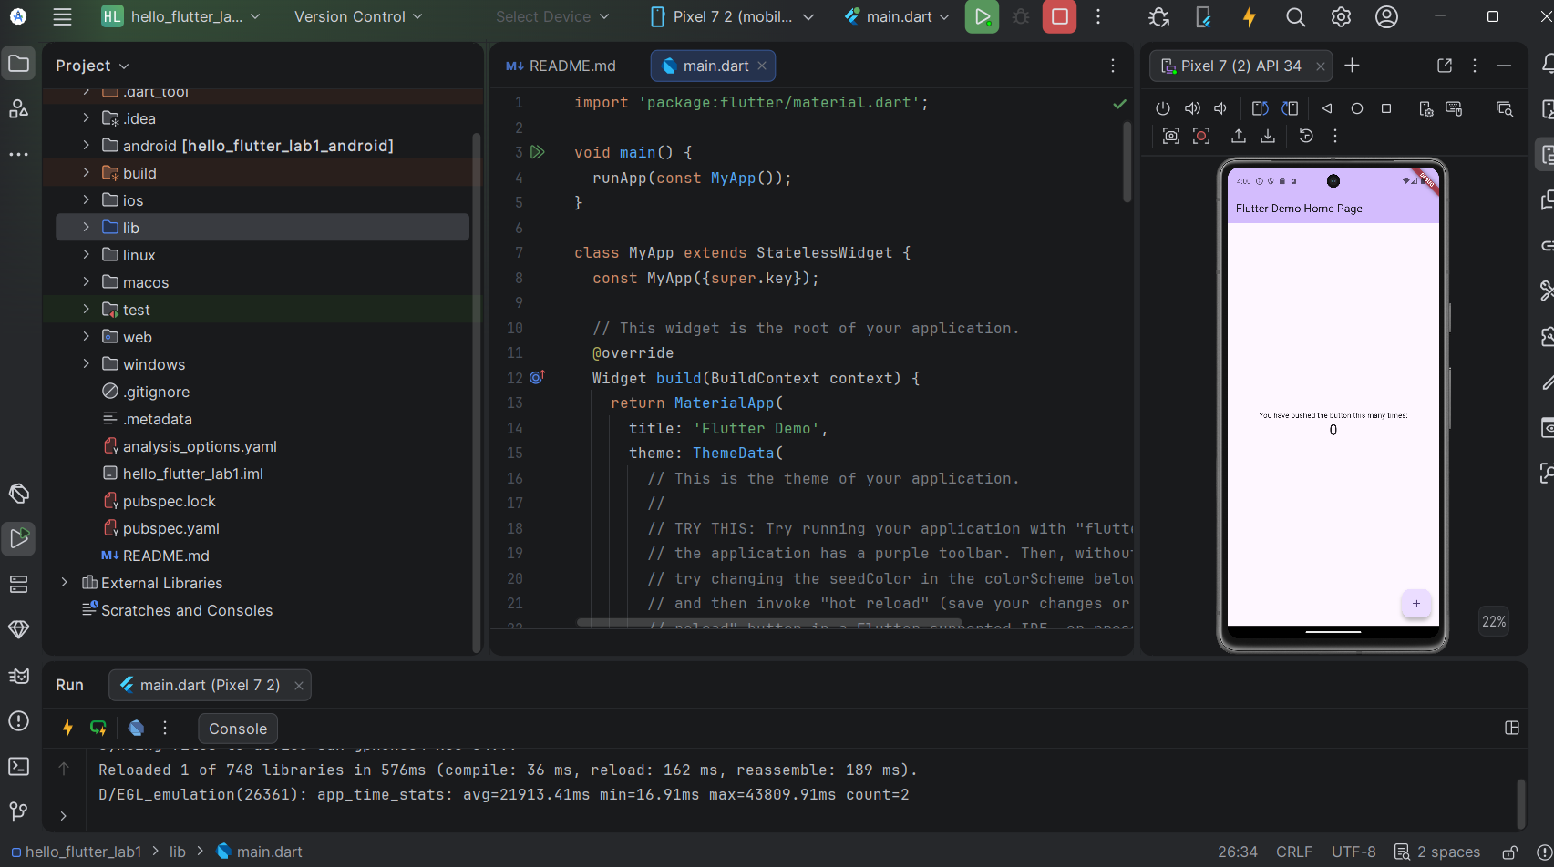

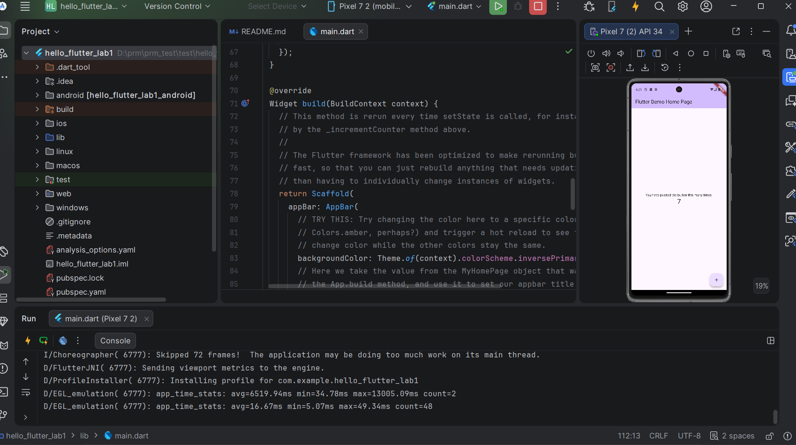

- Screenshot showing updated title via Hot Reload
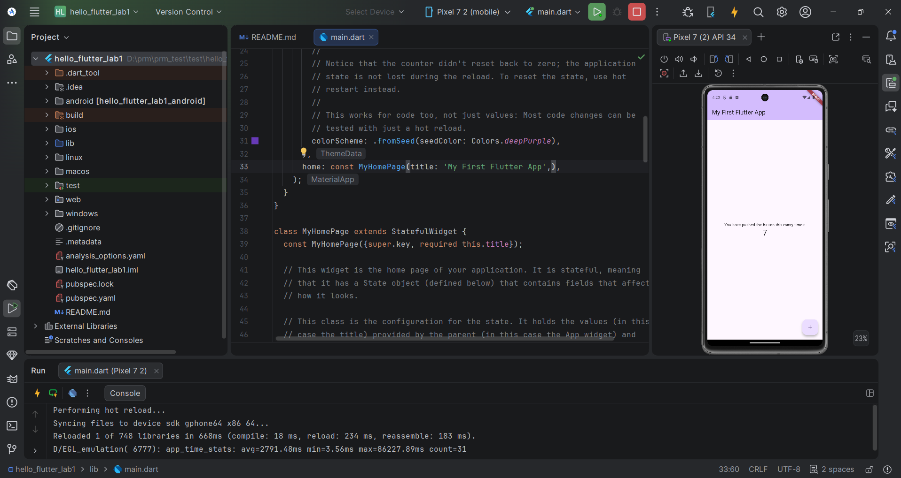

Exercise 3 – Customize Your First Flutter UI

Code:
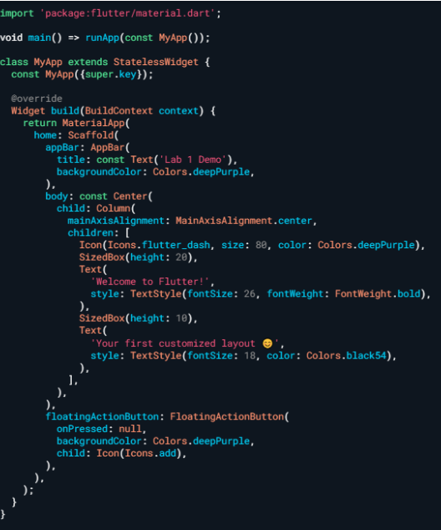

Perform Hot Reload and verify UI updates.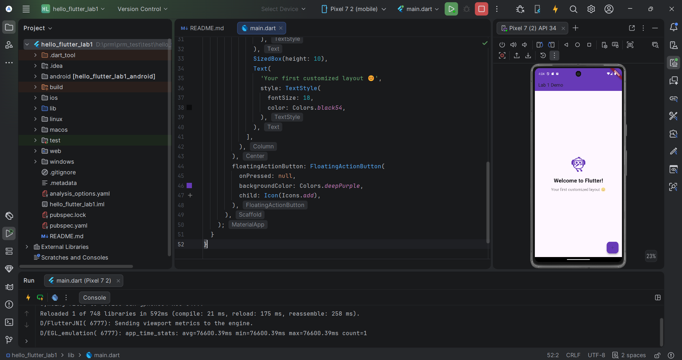

Modify colors/text and reload again
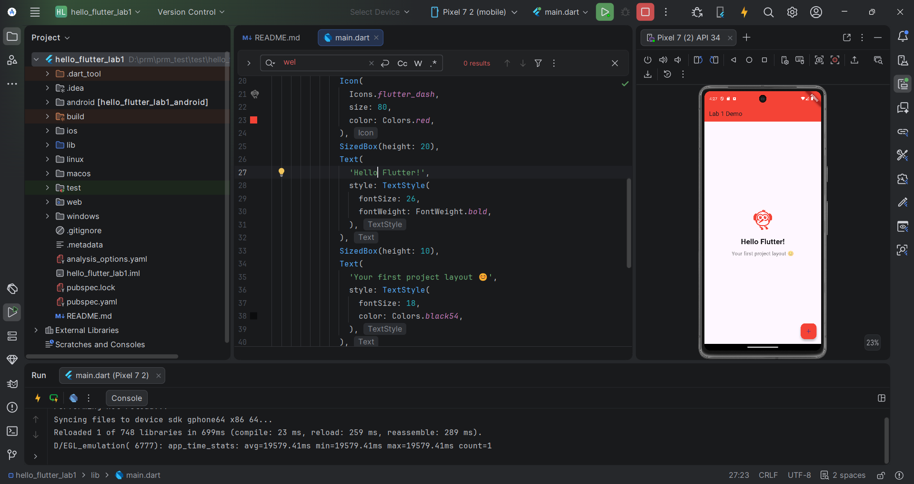

Exercise 4 – Reflection Questions
- Purpose of flutter doctor
Checks if Flutter and all required tools are installed correctly.
- Entry point of Flutter app
lib/main.dart
- Hot Reload vs Hot Restart
- Hot Reload: updates UI quickly, keeps app state.
- Hot Restart: restarts the whole app, resets state.
- How does runApp() build the widget tree?
runApp() takes the root widget of the application and attaches it to the screen. Flutter then builds a hierarchy of widgets called the widget tree, which defines the structure and UI of the application. How Flutter supports cross-platform development
Flutter uses one Dart codebase to build apps for Android, iOS, web, and desktop.
5.How Flutter supports cross-platform development
Flutter supports cross-platform development by using a single Dart codebase to run on multiple platforms such as Android, iOS, Web, and Windows (with separate libraries and directories for editing and deep customization). Flutter automatically generates the user interface using its own engine, so applications have a consistent interface and stable performance across different devices.

